|  |  |  |
| --- | --- | --- |
| NTG logo - reversed 300ppi 2 |  | DEPARTMENT OF EDUCATION |

Karama School

Annual Performance Report to the School Community

2016

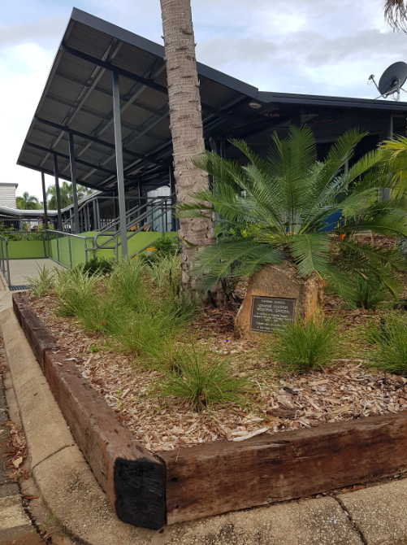



School Overview

Karama School is located in the heart of the northern suburbs of Darwin in the suburb of Karama. Karama School offers a dynamic, engaging educational and social emotional program for all students from Preschool to Year 6 with a 0 to 4 early learning Centre. Our schools current enrolment is 202 students made up of a wide variety of cultures (46% indigenous students, 65% total English as a Second Language students) that replicates the multicultural design of greater Darwin. This diverse mix is celebrated regularly across the school and wider community.

A specific focus is placed on Literacy and Numeracy development with a supportive whole school intervention program to cater for students in need and to further support classes with more academic capable students. Curriculum delivery is tailored to students needs as 30% (approx.) of students are identified at risk (special needs, social / emotional and academic).

The schools three core values Respect, Responsibility and Resilience, underpin all interactions between students, staff and the wider community.

# Our Mission

At Karama School we believe in a personal best orientated learning environment.

* Ensure a values based approach to all behaviour
* Promote appropriate learning activities which ensure success.
* Build positive staff, parent, student and community relationships.
* Provide an inclusive curriculum.

Our School Vision

* Achieving in a safe, supportive, innovative and sustainable learning community

Karama School offers a number of specialist learning opportunities that include music, cooking, gardening, wellbeing and community representative experiences to compliment the school’s student ability levelled, tailored educational programs.

**Karama School’s 2016 3 main priorities were:**

* **English**: Implement the Promoting Literacy Development (PLD) phonics program in P - 2
* **Intervention / Wellbeing:** Further establish, develop and implement a whole school intervention and wellbeing program
* **Leadership:** Ensure all staff have an ongoing Professional Development Plan with goals aligned to CLF (Capability and Leadership Framework) and AITSL (Australian Institute for Teaching and School Leadership) documentation

## 2016 strategies for maintaining/improving attendance incorporated:

* The average school attendance was 87.2%. The school undertook a comprehensive, consistent approach to attendance through the continued efforts of the schools Community Liaison, front office staff, regular community communication, the NT DoE attendance team and further positive initiatives within the school to encourage attendance and engagement in quality learning and wellbeing programs.

## 2016 teaching, learning and specialist programs included:

* Implementation of a whole school approach to reading and comprehension to incorporate teacher coaching and Professional Learning.
* A whole school spelling and grammar program (Soundwaves).
* A whole school mathematics approach, Meaningful Maths (M2) to incorporate teacher coaching and Professional Learning.
* Early Childhood, Promoting Literacy Development (PLD) implementation
* Incorporating the NT Preschool Curriculum into the programming cycle
* A whole school values and wellbeing program.
* A cooking, gardening / Health and school wide Science program.
* A Music Arts program offered across the school.
* Year 6 students participated in Transition Programs with Sanderson Middle School.
* Music programs delivered by the NT Music School across the school for years 4 to 6.
* Sports Gala and inter-school days participation
* The Early Learning Years Framework (ELYF) and National Quality Standards continued to be implemented across the Early Years including the Early Learning Centre, Preschool, and Transition.
* Special celebrations and community events throughout the year (Community Breakfast, Harmony Day, Sports days, Mother’s / Father’s day breakfasts, Science Fair and Awards and music Assemblies
* Personal Learning Plans (PLPs) for all students

**Our Staff**

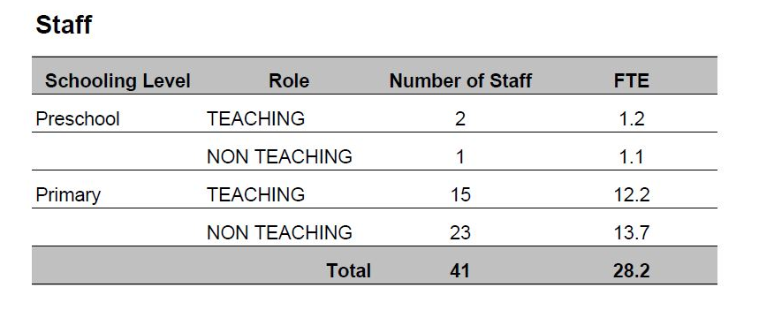

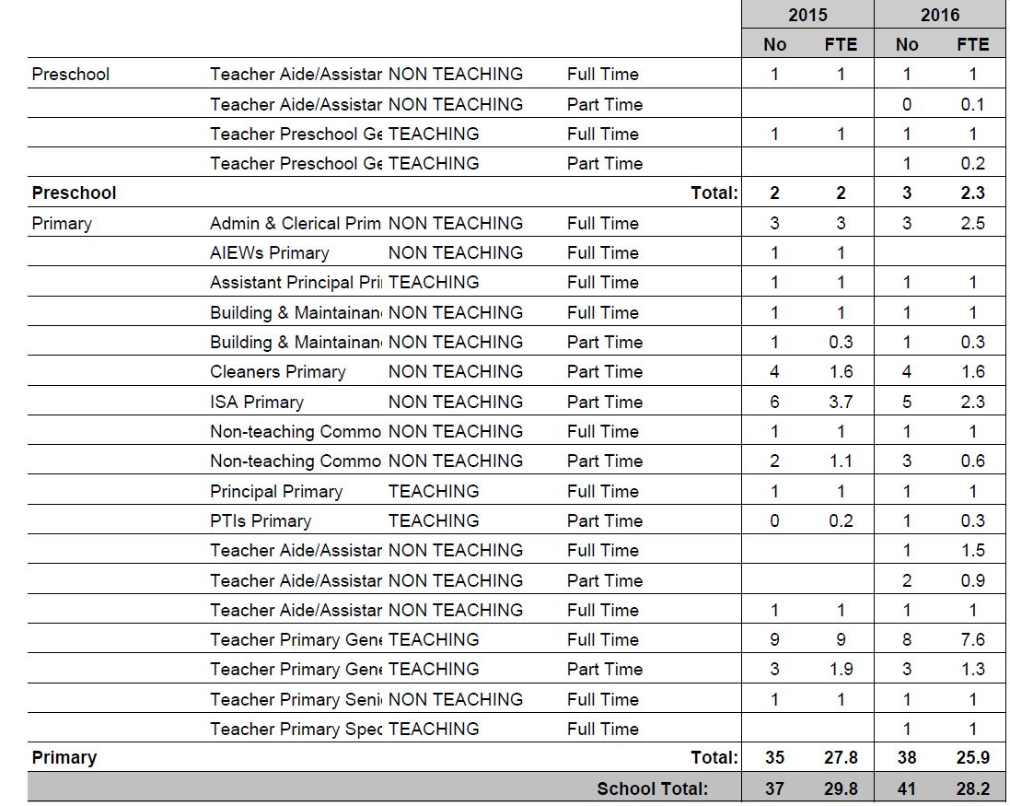

Additional staff employed throughout the School Council included:

* four SESAs (Special Education Support Assistants)
* school cleaning crew
* a part time gardener
* a road safety assistant
* a private contractor to manage the canteen

Unfortunately, in 2016 there were a number of changes to the overall makeup of the teaching staff at Karama School.

These changes were due to a number of differing, at times unforeseen circumstances. However, the school’s students and ongoing staff were able to deal with these changes professionally. A high quality learning program and the accurate maintenance of the schools financial accounts was maintained during these changes. This intern is a credit to the staff, students and community.

*Outline workforce composition, including number of staff that identify as Indigenous, staff attendance, staff qualifications, and distinctive skills of staff.*

*Where the qualification level of teaching staff is unknown, schools may include a statement such as:*

*All teaching staff met the professional standards for teachers in the Northern Territory, including having obtained appropriate qualifications for teaching and abiding by the Code of Ethics for Northern Territory teachers.*

**Our Students**

There was an overall average of 202 students enrolled at Karama School in 2016 with an average attendance rate of 87.2%. This enrolment cohort was comprised of approximately 46% Indigenous and 65% total EAL/D.

Students were allocated to 8 classes from preschool (2 X 0.5 full day sessions) to year 6.

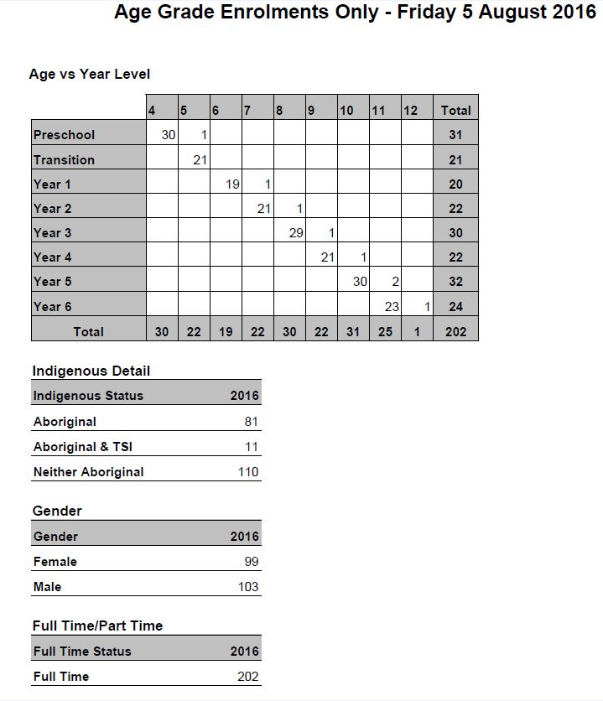

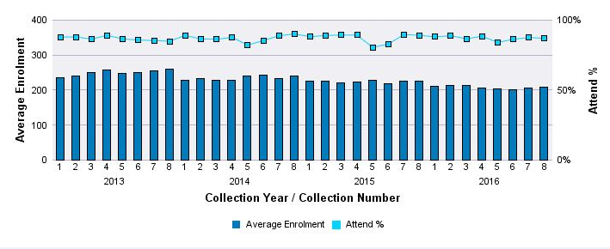

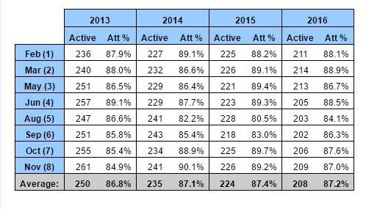

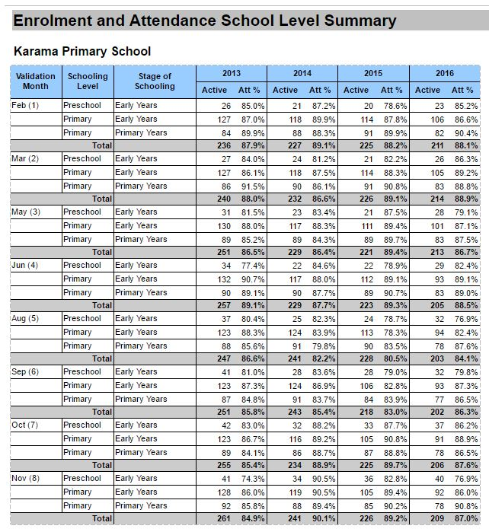

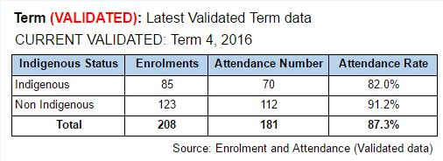

Principal's Report

2016 was a big year for Karama School. During this period a number of strategic staffing and educational changes were made to implement new teaching and learning practices and further promote the ongoing successful programs that had been established and implemented at the school.

Karama School has a strong relationship with the local wider school community. This is due to the consistency of long term staff, a calm professional approach to the challenges and changes adopted within the school and the quality Teaching and Learning Program being delivered and continually strengthened.

Throughout the year, initiatives across the school included:

* Teacher support with the Assistant Principal as the curriculum coach with regular weekly sessions for both Literacy and numeracy were maintained
* Teaching and learning programs were redesigned with associated expectations
* The Tata centre grew to include; specific parent support programs and individual, small group and whole class wellbeing programs
* Meaningful Maths – M2 was further strengthened through participating in Professional Leaning (PL) sessions and the schools Assistant Principal continued to participate as an integral member of the steering committee
* Personal learning plans for all students and the associated parent / community meetings were conducted
* whole school curriculum and support documents were developed and updated for 2017, ongoing
* The Smith Family student, school and community partnership was strengthened
* new partnerships with Relationships Australia and Anglicare were established
* The Sanderson Alliance continued to take shape to assess areas of social and emotional need
* Student wellbeing and intervention was maintained and further supported throughout the Tata centre, the schools Community Liaison, Special Education Teacher and external departmental and external agencies
* The school introduced the KidsMatter program
* The schools infrastructure was upgraded to include the external surfaces, the EC classroom, the stage 1 refurb of the Library and an internal rebuild of the administration building
* Many internal PL opportunities were accessed and also facilitated by the staff internally
* strategic professional learning sessions were conducted throughout the year to further develop staff and practice across the school

In all, 2016 was a year that witnessed some change to the fundamental requirements to further deliver and promote a quality education program underpinned by a clear documented and curriculum aligned program. This was supported with Professional Learning, team coaching and whole staff sharing practices.

Through these strategically aligned practices, resource acquisition and recruitment during 2016, the school is set to further build on the already established foundations and compliment these practices with an ongoing review process. This will ensure that the best possible education practice is being delivered to all students at Karama School.

Tim Morgan

Principal Karama School

***Schools may choose to include a report from the principal that provides a summary of the key decisions, events and achievements of the school.***

Teaching and Learning

In 2016, the teaching and learning focus areas included the introduction of the EC PLD program, reading/comprehension, spelling - further expanding with the soundwaves program and numeracy through strengthening the alignment of the school with the M2 maths program and steering committee. These areas became a focus for professional learning days and staff meeting sessions.

**2016 NAPLAN comparison 2015 to 2016 data for year 3 students to year 5**

Data analysis indicates that in **Year 3** students improved results to be at or above in 4 of the 5 assessed areas. Reading, Writing, Grammar / Punctuation and Numeracy.

(Indicated by the green bar, 2016 below)

1st bar – School result, 2nd bar - NT average and 3rd bar - Australian average

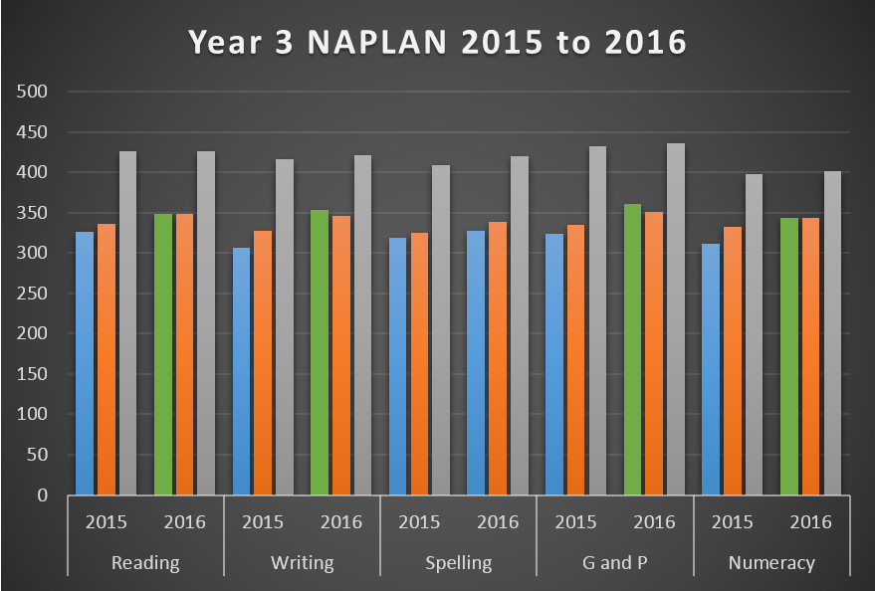

Data analysis indicates that in **Year 5** students improved results to be at or above in 4 of the 5 assessed areas. Reading, Writing, and Spelling.

(Indicated by the green bar, 2016 below)

1st bar – School result, 2nd bar - NT average and 3rd bar - Australian average

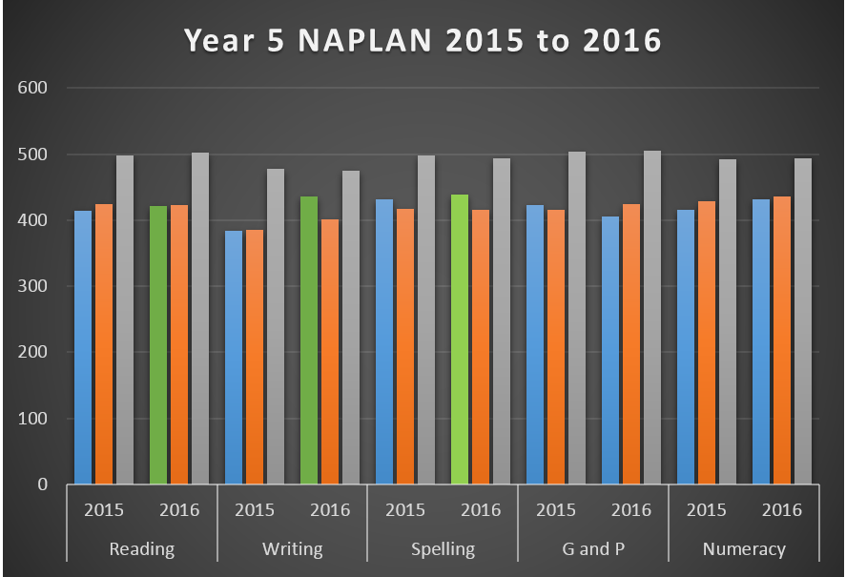

Wellbeing

In 2016 the school continued building strategies to support students academically, socially and emotionally to enable them to achieve to the best of their ability. The school Wellbeing team placed a major focus on embedding the school’s values of **Respect, Responsibility** and **Resilience** into the school culture, classrooms and playground.

In term three, the KidsMatterprogram was introduced into the school and wider community. The KidsMatterprogram supplies the necessary framework to continue to build wellbeing initiatives.

**School attendance**

There was an overall average of 202 students enrolled at Karama School in 2016 with an average attendance rate of 87.2% throughout 2016. This enrolment cohort was comprised of approximately 46% Indigenous and 65% total EAL/D.

**Strategies for Achievement of Target;**

* In 2016 social skills and leadership programs took place to support and respond to the needs of the school community.
* Students also had the opportunity to seek individual support from wellbeing support staff and the Home Liaison.
* Links were established with the wider community to provide additional wellbeing support.
* The wellbeing team looked into sustainable wellbeing support structures, highlighting the importance of wellbeing and working to establish a whole school approach/program/framework
* Year 6 students worked closely with the Community Liaison and SMS staff to assist with a smooth transition into year 7 for 2017
* Tata Family Centre provided wellbeing support for families and their children aged 0-4 through supported playgroups, links with child health, providing parenting support and referral pathways to other support networks.
* Professional learning provided to staff to support the wellbeing of the school community.
* School events included;

‘Green’ (school facilitated) light discos

Post NAPLAN celebration, Beach Day

Whole school community Breakfast

PLP meetings

Individual and class attendance awards

Year 3 to 6 school camps

ANZAC Day remembrance

Harmony Day festival

Mother’s and Father’s day Breakfasts

NT School of Music instruction

The school choir and drumming group

Annual School concert

Science Fair

Dry season concert

School sport opportunities

Term attendance awards assembly week 10

***In this section the school should reflect on their student wellbeing and engagement outcomes and discuss their achievements and progress towards achieving targets for improvement, including presentation of key performance measures.***

***Schools provided with supplementary funding, such as funding under a National Partnership, explicitly identify the progress and achievement under that partnership, including quantitative or qualitative outcomes. For example: Under the National Partnership for [insert title], the school has [insert strategy/activity and target cohort]. This support has seen [insert quantitative/ qualitative information].***

**Participation, Transitions and Pathways**

In 2016 Karama School partnered further with the five local area schools to form the Sanderson HUB. The focus is to further develop transition strategies, programs and approaches to promote the movement of students from Karama to Sanderson Middle school and align teaching practices.



Sanderson Alliance is a culture of collaboration/learning community. Its mission is to build a culture of high quality learning in all our schools through a collective culture of professional learning. We operate as a collective through collaboration to support schools in our hub to individualize and contextualize hub projects, and grow educators to support improved learning outcomes for all students.

We operate on a Collective Impact Model of change

**Five Conditions of Collective Impact**

|  |  |
| --- | --- |
| Common Agenda | All participants have a shared vision for change including a common understanding of the problem/s and a joint approach to solving it through agreed upon actions. |
| Shared Measurement | Collecting data and measuring results consistently across all participants ensures efforts remain aligned and participants hold each other accountable. |
| Mutually Reinforcing Activities | Participant activities must be differentiated while still being coordinated through a mutually reinforcing plan of action. |
| Continuous Communication | Consistent and open communication is needed across the many players to build trust, assure mutual objective and create common motivation. |

**Three Preconditions for Collective Impact**

1. An influential champion/s
2. Adequate financial resources
3. A sense of urgency of change

**Key Components of Collective Impact**

* A description of the problem, informed by solid research
* A clear goal for the desired change
* A portfolio of key strategies to drive change
* A set of principles that guide the group’s behaviour
* An approach to evaluation that lays out how the collective impact initiative will obtain and judge the feedback on its efforts

**Our key pillars are to:**

* Lay the foundations in our students for future learning and growth, and active participation in the Australian community.
* Emphasize the important of knowledge, skills and understanding of the learning areas, general capabilities, and cross curriculum priorities, to support 21st century learning. (Melbourne Declaration/Australian Curriculum).
* Promote excellence and equity.
* Facilitate our young people as successful learners, confident and creative individuals and active, informed citizens.
* Continuously improve teacher efficiency
* Improve student outcomes in literacy and numeracy

Also, Karama teamed with the commonwealth - Universal Access to Pre-school Project. This was a valuable opportunity to support students and families to transition into the school and through this update the facilities and improves resources.

**0-3 YR UNIVERSAL ACCESS TO PRE-SCHOOL PROJECT REPORT**

**Background**

The 0-3 year old Universal Access to Pre-school Project was a wonderful opportunity for Karama School to redevelop and upgrade the Early Childhood areas, resources, advertise and implement the changes to the new Early Learning area. Through redeveloping this area to combine the existing Tata centre to be adjacent to the Preschool, a geographical / natural link was established to combine the two Early Learning centres.

**Aim**

The aim of the project was to ‘capture’ local families to encourage them to participate in the activities being offered within the school and through time, have their children then enrol in the School’s preschool. Through this, a better understanding and awareness of the access to preschool and the importance of education, health and parenting was focused on.

**Objective**

* Increase Indigenous peoples capacity to access pre-school initiatives provided by local schools.
* Increase Indigenous urban community enrolments in attending pre-school.
* Develop the Indigenous people’s capacity to create collaborative working partnerships with school.
* Support and engage Indigenous parents and carers in school culture and school initiatives.

**Target Audience**

Parents and carers of Indigenous children aged between 0-3 years of age

**Key Priorities**

* To increase the number of students in the early years cohort
* Number of children participating in transition to school activities/programs/workshops. (Targeting Pre-school/ Early Year’s cohorts – Tata centre)
* Number of students who enrol in the school as a result of this intervention.
* Number of parents participating in workshops/orientation Timeline, Delivery and outcomes

Partnerships

The Smith Family, support to the Tata Centre, whole school music programs and families with learning for life scholarships.

Tata Family Centre invite all Northern Suburbs families to come and join our free and fun programs for our Families Each Term we would like to run new and exciting Programs based on your families interests and needs.

These programs included;

• Healthy Cooking

• Craft / sewing for Mums

• Lets read for families

• Play groups

• Women’s/mums and bubs exercise

• BABY FAST/FAST

• Mums/Dads groups

• Financial Literacy

• Triple P Parenting

• 123 Magic

• Gardening in the tropics

• Reading is as Easy as 123

• Family Rhyme Time

• Social skills groups and support for primary school aged children.

• Community information and referrals

*In this section the school should reflect on their student participation, pathway and transition outcomes and discuss their achievements and progress towards achieving targets for improvement, including presentation of key performance measures.*

*Schools provided with supplementary funding, such as funding under a* ***National Partnership,*** *explicitly identify the progress and achievement under that partnership, including quantitative or qualitative outcomes. For example: Under the National Partnership for [insert title], the school has [insert strategy/activity and target cohort]. This support has seen [insert quantitative/ qualitative information].*

***Focus schools*** *identified under the Aboriginal and Torres Strait Islander Education Action Plan include an overview of strategies addressing readiness for school and implementation of an evidence-based attendance strategy and progress towards targets.*

*Under**the Aboriginal and Torres Strait Islander Education Action Plan,* ***all schools with a secondary program*** *are to include progress and achievement on:*

* *Strategies implemented to increase the retention of Aboriginal and Torres Strait Islander students to year 12, including innovative and tailored learning opportunities, mentoring and targeted case management*
* *Pathways and improved access to school-based accredited training, including traineeships and apprenticeships for Aboriginal and Torres Strait Islander students in years 10-12.*
* *Case management of Aboriginal and Torres Strait Islander students undertaking school-based traineeships and being linked to employment services, including number and types of employment services*
* *Career services for Aboriginal and Torres Strait Islander students and their families to support informed career and study choices*
* *School business community partnerships that extend learning beyond the classroom to increase student engagement; deepen learning experiences and improve educational outcomes.*

*Under the* ***National Education Agreement*** *it is a requirement that schools report on post school destinations such as number undertaking further study, training, or in work. This information may be captured through student exit surveys/interviews or identified through planning of personalised learning strategies.*

*In this section the school should reflect on their organisational health and learning outcomes and discuss their achievements and progress towards achieving targets for improvement, including presentation of key performance measures.*

***All schools*** *must include:*

* *results of parent, student and teachers satisfaction which may be captured through school survey*
* *School operational strategies implemented to meet the needs of the local Aboriginal and Torres Strait Islander community. Strategies may include extended operating hours, onsite or co-located services such as health care, after school hours study support, sporting programs, child care and family support programs.*

*Schools provided with supplementary funding, such as funding under a* ***National Partnership,*** *explicitly identify the progress and achievement under that partnership, including quantitative or qualitative outcomes. For example: Under the National Partnership for [insert title], the school has [insert strategy/activity and target cohort]. This support has seen [insert quantitative/ qualitative information].*

***Focus schools*** *identified under the Aboriginal and Torres Strait Islander Education Action Plan provide progress and achievement of the implementation of school-community partnership agreement, including strategies that have supported improved engagement, well-being and educational outcomes and number of family forums held this year to engage Aboriginal and Torres Strait Islander families.*

Leadership

Leadership at Karama School in 2016 was predominantly focused on the implementation and maintenance of:

* Internal promotion of successful staff via the merit system to undertake leadership roles
* Establishment of Project Teams in teaching areas to reflect and implement effective teaching and learning strategies.
* Opportunities for constructive self-reflection and meaningful feedback from peers in coaching roles through classroom observations/walkthroughs.

The school initiated programs to build the leadership capacity of staff through:

* ICT competencies and the integration of digital technologies across all curriculum areas.
* Whole School professional learning
* NAPLAN Writing Marking Panel
* Writing Moderation
* Numeracy Workshops
* Introduction wellbeing strategies and procedures
* School based data analysis professional learning days for all staff.
* Visible Learning coaches
* Implementation of whole staff workshops and school.
* Creating a whole school approach to high expectations that permeate, building a challenging culture in the classroom.
* Teacher/Leaders who demonstrate the highest expectations show their students that they expect rigorous, challenging, high quality work.
* Implementing instructional plans and programs
* Engaging students to remain on task by delivering quality tasks Adopting confirming / moderating practices that communicate high expectations

*In this section the school should reflect on their community engagement outcomes and discuss their achievements and progress towards achieving targets for improvement, including presentation of key performance measures.*

*Schools provided with supplementary funding, such as funding under a* ***National Partnership,*** *are to explicitly identify the progress and achievement under that partnership, including quantitative or qualitative outcomes. For example: Under the National Partnership for [insert title], the school has [insert strategy/activity and target cohort]. This support has seen [insert quantitative/ qualitative information].*

***Focus schools*** *identified under the Aboriginal and Torres Strait Islander Education Action Plan are to provide progress and achievement of principal participation in leadership program to assist in leading improvement in learning outcomes of Aboriginal and Torres Strait Islander students.*

**ATTACHMENT A**

**Audited Financial Statements**

# KARAMA PRIMARY SCHOOL COUNCIL INCORPORATED

**ANNUAL FINANCIAL STATEMENTS**

**for the year ending 31 December 2016**

**SUSANNE LEE & ASSOCIATES PTY LTD**

CERTIFIED PRACTISING ACCOUNTANTS

Phone: 0418897757

Email: [suelee@bigpond.net.au](mailto:suelee@bigpond.net.au)

PO Box 475 Mudgeeraba QLD 4213

ABN: 29 161 528 481

**KARAMA PRIMARY SCHOOL COUNCIL INCORPORATED**

**FINANCIAL REPORT**

**YEAR ENDED 31st December 2016**

|  |  |
| --- | --- |
| **CONTENTS** | **PAGE** |
| Council Statement | 3 |
|  |  |
| Independent Audit Report | 4 |
|  |  |
| Statement of Financial Position | 5 |
|  |  |
| Income Statement | 6-7 |
|  |  |
| Notes to and forming part of the Accounts | 8 |
|  |  |

**KARAMA PRIMARY SCHOOL COUNCIL INCORPORATED**

**FINANCIAL STATEMENTS**

**FOR THE YEAR ENDED 31 DECEMBER 2016**

As Chairperson of the Karama Primary School Council Incorporated I state to the best of my knowledge and belief that the accompanying financial report, which has been prepared by the School’s management in accordance with the reporting requirements of the Northern Territory Department of Education does fairly reflect the financial position of the School and its performance for the year ended 31 December 2016.

At the date of this statement, I have obtained assurance from the School Principal that there were reasonable grounds to believe that the School will be able to pay their debts as and when they fall due.

Chairperson

Dated:

The accompanying notes form part of the financial report and are to be read in conjunction with the attached audit report.

**INDEPENDENT AUDIT REPORT**

***To the members of Karama Primary School Council Incorporated***

We have audited the accompanying financial report of Karama Primary School Council Incorporated, which comprises the Statement of Financial Position as 31/12/2016 and the Income Statement for the year then ended, notes comprising a summary of significant accounting policies and other explanatory information and the School Council statement.

***School Council responsibility for the financial report***

The School Council of Karama Primary School Council Incorporated are responsible for the preparation and fair presentation of the financial report in accordance with Australian Accounting Standards and the *Education Act* where applicable and for such internal control as the Council determine is necessary to enable the preparation and fair presentation of a financial report that is free from material misstatement, whether due to fraud or error.

***Auditor’s responsibility***

Our responsibility is to express an opinion on the financial report based on our audit. We conducted our audit in accordance with Australian Auditing Standards. Those standards require that we comply with relevant ethical requirements relating to audit engagements and plan and perform the audit to obtain reasonable assurance about whether the financial report is free from material misstatement.

An audit involves performing procedures to obtain audit evidence about the amounts and disclosures in the financial report. The procedures selected depend on the auditor’s judgment, including the assessment of the risks of material misstatement of the financial report whether due to fraud or error. In making those assessments, the auditor considers internal control relevant to the Schools preparation and fair presentation of the financial statements in order to design audit procedures that are appropriate in the circumstances, but not for the purpose of expressing an opinion on the effectiveness of the entity’s internal control. An audit also includes evaluating the appropriateness of the accounting policies used and the reasonableness of accounting estimates made by the School as well as evaluating the overall presentation of the financial report.

We believe that the audit evidence we have obtained is sufficient and appropriate to provide a basis for our audit opinion.

***Independence***

In conducting our audit, we have complied with the independence requirements of the Australian professional accounting bodies.

***Audit Report qualification***

*Basis for qualified opinion*

Receipts from cash self-generated funds are a source of revenue for the Karama Primary School Council Incorporated. The Karama Primary School Council Incorporated has determined that it is impracticable to establish control over the collection of cash revenue prior to entry in its financial records. Accordingly, as the evidence available to us about cash revenue was limited, our audit procedures for this revenue had to be restricted to the amounts recorded in the financial records. We therefore are unable to express an opinion on whether cash self-generated revenue obtained by the Karama Primary School Council Incorporated is complete.

*Qualified opinion*

In our opinion, except for the possible effects of the matter described in the Basis for Qualified Opinion paragraph, the financial report Karama Primary School Council Incorporated presents fairly in all material respects in accordance with the accounting policies described in Note 1 to the financial statements, the financial position of the Karama Primary School Council Incorporated at 31 December 2016 and its financial performance for the year then ended.

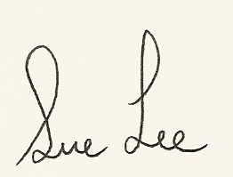

Susanne Lee FCPA

Director

9 February 2017

|  |  |  |
| --- | --- | --- |
| **KARAMA PRIMARY SCHOOL COUNCIL INCORPORATED** | | |
| **Statement of Financial Position** | | |
| **December 2016** | | |
|  | This Year | Last Year |
| **ASSETS** |  |  |
| **Current Assets** |  |  |
| **Cash at Bank** |  |  |
| CBA Cheque Account | $10,921.54 | $13,637.06 |
| **Cash on Hand** |  |  |
| Petty Cash & Float | $1,100.00 | $1,100.00 |
| **On call or short term deposits** |  |  |
| MasterCard | $377.05 | $755.08 |
| Net-bank Saver Account | $250,175.99 | $208,340.89 |
| Bendigo Investment Account | $4,433.88 | $0.009 |
| **Total on Call or Short Term Deposits** | **$254,986.92** | **$209,095.97** |
| **Trade Debtors** |  |  |
| Accounts Receivable | $0.00 | $2,534.93 |
| **Prepayments** |  |  |
| Prepaid Insurance | $925.61 | $926.96 |
| **Inventories** |  |  |
| Uniform Stock on Hand | $9,220.00 | $10,756.05 |
| **Other Current Asset** |  |  |
| FFE Recovery | $35,053.10 | $0.00 |
| **Total Current Assets** | **$312,207.17** | **$238,050.97** |
| **Non-Current Assets** |  |  |
| Plant & Equipment at Cost | $24,888.00 | $24,888.00 |
| Accumulated Depreciation | -$19,834.46 | -$16,727.34 |
| **Total Non-Current Assets** | **$5,053.54** | **$8,160.66** |
|  |  |  |
| **Total ASSETS** | **$317,260.71** | **$246,211.63** |
|  |  |  |
| **LIABILITIES** |  |  |
| **Current Liabilities** |  |  |
| **Deposits Held - 3rd Parties** |  |  |
| Net Deposits Held - 3rd Parties | $8,473.08 | $6,101.50 |
| **Trade Creditors** |  |  |
| Accounts Payable | $14,172.86 | -$1,057.61 |
| **GST Liabilities** |  |  |
| GST Collected | $0.00 | $230.45 |
| GST Paid | -$597.50 | $0.00 |
| GST Adjustment Pending | $0.00 | **-$136.36** |
| **Total GST Liabilities** | **-$597.50** | **$94.09** |
| **Other Accrued Expenses** |  |  |
| Accrued Expenses | $9,740.54 | $12,271.98 |
| **Employee Entitlements** |  |  |
| Long Service Leave Entitlement | $17,600.00 | $11,553.00 |
| **Total Current Liabilities** | **$49,388.98** | **$28,962.96** |
| **Non-Current Liabilities** |  |  |
| **Total Non-Current Liabilities** | **$0.00** | **$0.00** |
|  |  |  |
| **Total LIABILITIES** | **$49,388.98** | **$28,962.96** |
|  |  |  |
| **Net ASSETS** | **$267,871.73** | **$217,248.67** |
|  |  |  |
| **EQUITY** |  |  |
| Accumulated Funds | $217,248.67 | $315,400.45 |
| Current Year Operating Surplus/(Deficit) | $50,623.06 | -$98,151.78 |
|  |  |  |
| **Total EQUITY** | **$267,871.73** | **$217,248.67** |

The accompanying notes form part of the financial report and are to be read in conjunction with the attached audit report.

|  |  |  |  |
| --- | --- | --- | --- |
| **KARAMA PRIMARY SCHOOL COUNCIL INCORPORATED** | | | |
| **Income Statement** | | | |
| **January-December 2016** | | | |
|  | | This Year | Last Year |
| **INCOME** | |  |  |
| **Grants and Subsidies** |  |  |
| Commonwealth Grants via DoE | $19,683.20 | $42,701.00 |
| Other Grants from DoE | $600,070.02 | $601,654.56 |
| Other Grants from NTG Departments | $90,890.39 | $92,676.98 |
| 3rd Party Grants - External | $90,650.47 | $59,382.68 |
| **Total Grants and Subsidies** | **$801,294.08** | **$796,415.22** |
| **Sale of Goods and Services** |  |  |
| School Council Projects | $45,452.82 | $45,117.49 |
| Student Activities | $13,926.00 | $16,054.00 |
| **Total Sale of Goods and Services** | **$59,378.82** | **$61,171.49** |
| **Interest Received** |  |  |
| Interest Received | $4,639.58 | $7,996.90 |
| **Miscellaneous Income** |  |  |
| Receipts/Reimbursements other Govt. Schools | $782.63 | $1,881.81 |
|  |  |  |
| **Total INCOME** | **$866,095.11** | **$867,465.42** |
|  |  |  |
| **EXPENSES** |  |  |
| **Employee Expenses** |  |  |
| Salaries & Related Expenses | $312,893.78 | $314,806.75 |
| Superannuation | $28,582.11 | $28,147.72 |
| **Total Employee Expenses** | **$341,475.89** | **$342,954.47** |
| **Purchase Of Goods & Services** |  |  |
| School General Expenses | $50,362.70 | $123,239.54 |
| Administrative Expenses | $12,157.94 | $16,173.75 |
| Motor Vehicle Expenses | $96.68 | $214.49 |
| Student Activities | $13,074.50 | $25,202.59 |
| Student Information Technology | $21,380.86 | $46,244.54 |
| Admin It and Communication | $39,232.84 | $28,165.48 |
| Curriculum | $30,282.49 | $38,091.48 |
| School Non-Core Activities | $31,563.86 | $11,327.19 |
| Payments to other Government Schools | $50.00 | $2,869.29 |
| **Total Purchase of Goods & Services** | **$198,201.87** | **$291,528.35** |
| **Repairs & Maintenance** |  |  |
| Urgent Minor Repairs | $88,616.94 | $75,152.59 |
| Non-Urgent Minors | $5,111.32 | $2,200.00 |
| **Total Repairs & Maintenance** | **$93,728.26** | **$77,352.59** |
| **Depreciation & Amortisation** |  |  |
| Depreciation | $3,107.12 | $14,344.33 |
| **Property Management** |  |  |
| Essential Services | $161,687.15 | $166,829.93 |
| Cleaning | $14,219.11 | $11,650.14 |
| Grounds | $23,926.39 | $30,001.80 |
| Property Management Other | $8,926.26 | $35,501.04 |
| **Total Property Expenses** | **$208,758.91** | **$243,982.91** |
| **Other Administrative Expenses** |  |  |
| Administrative Expense | $200.00 | $0.00 |
|  |  |  |
| **Total EXPENSES** | **$845,472.05** | **$970,162.65** |
|  |  |  |
| **Operating SURPLUS/(DEFICIT)** | **$20,623.06** | **($102,697.23)** |

|  |  |  |  |
| --- | --- | --- | --- |
| **KARAMA PRIMARY SCHOOL COUNCIL INCORPORATED** | | | |
| **Income Statement** | | | |
| **January-December 2015** | | | |
|  | | This Year | Last Year |
|  |  |  |
| **Other INCOME** |  |  |
| Capital/CYCLICAL Maintenance Grants DoE | $79,933.21 | $0.00 |
| Cluster Funding Income | $0.00 | $4,545.45 |
| Devolved DoE Corp Income | $30,000.00 | $0.00 |
| **Total OTHER INCOME** | **$109,933.21** | **$4,545.45** |
|  |  |  |
| **Other EXPENSES** |  |  |
| Capital Grant Expenses | $79,933.21 | $0.00 |
|  |  |  |
| **Net PROFIT/(LOSS)** | **$50,623.06** | **($98,151.78)** |

The accompanying notes form part of the financial report and are to be read in conjunction with the attached audit report.

**KARAMA PRIMARY SCHOOL COUNCIL INCORPORATED**

**NOTES TO AND FORMING PART OF THE FINANCIAL STATEMENTS**

**for the year ended 31st December 2016**

**Note 1: Statement of Accounting Policies.**

These financial statements are a special purpose financial report prepared for the Council in order to satisfy the requirements of the Northern Territory Department of Education and the School Council Constitution. In accordance with the powers in S71H(1) of the Education Act (*NT),* the Secretary of the Department of Education has prescribed the manner in which the School Council is to prepare this report, and in so doing, has determined the accounting policies to be adopted in preparing the report.

In general, the statements have been prepared on the accruals basis and under the historic cost convention.

1. **Scope of the School Council’s financial reporting**

This financial report records only the revenues and associated expenditure of funds allocated to, or raised by, the School. It does not include teaching and administrative staff salaries and allowances, including leave provisions, since these personnel are employees of the Department, and their employment costs are met by the Department. The School does receive funding for casual relief teachers and other relief staffing, and although this activity is controlled by the School’s management on behalf of the Department, it is included in this financial report.

1. **Revenue recognition**

Revenue from grants is recognised upon receipt, except where invoices are raised on the Department for reimbursable funded items, including essential services, property management and some relief personnel. In those instances, the revenue is recognised when the invoice is raised. Minor New Works and Capital grant balances are transferred to the balance sheet at year end. Receipts from fund raising activities are recognised when they have been received by the School.

1. **Income Tax**

The School is exempt from income tax under provisions of the Income Tax Assessment Act that apply to Government bodies.

1. **Capital expenditure**

The School does not own the land on which the School is situated, so does not record the cost or value of the buildings on that land. The land and buildings are assets of the Northern Territory Government.

From the 2010 financial year and in accordance with the Department of Education requirement, only assets with a cost of $10,000 or higher are recorded as an asset. Only assets exceeding that amount are carried as recorded in the balance sheet.

1. **Depreciation**

Assets carried in the balance sheet will be depreciated on a straight line basis @ 15%.

**(f) Receivables**

Revenue from reimbursement from the Department of Education for over-expenditure in grant funded activities is brought to account when received.

**(g) Inventories**

Inventories are measured at the lower of purchase cost and net realisable value.

**(h) Employee Entitlements**

The School employs staff on casual, award and/or contract arrangements and has incurred a liability for employee entitlements.

The accompanying notes form part of the financial report and are to be read in conjunction with the attached audit report.

**ATTACHMENT B**

**NAPLAN data**

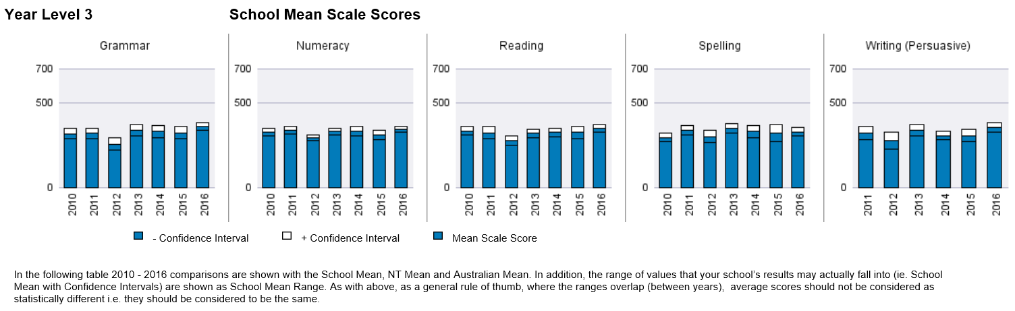

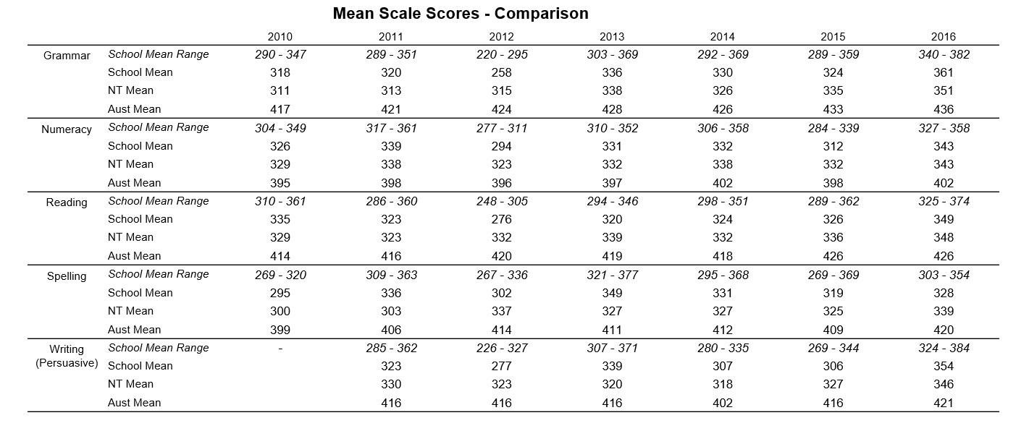

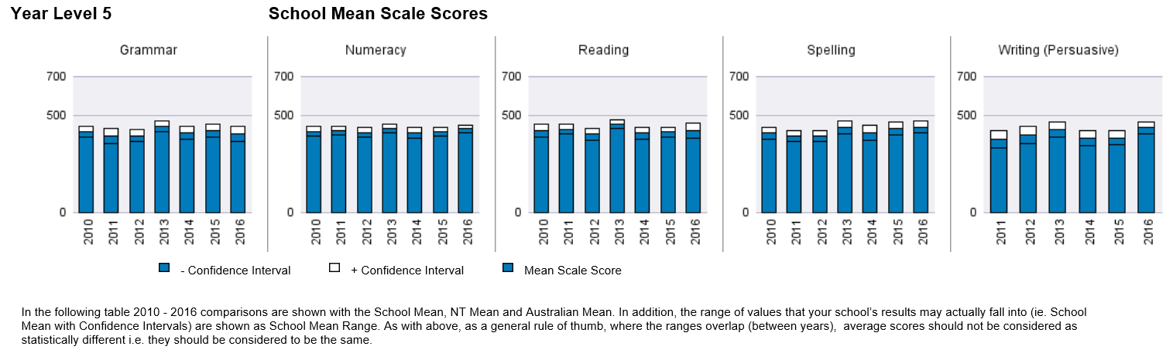

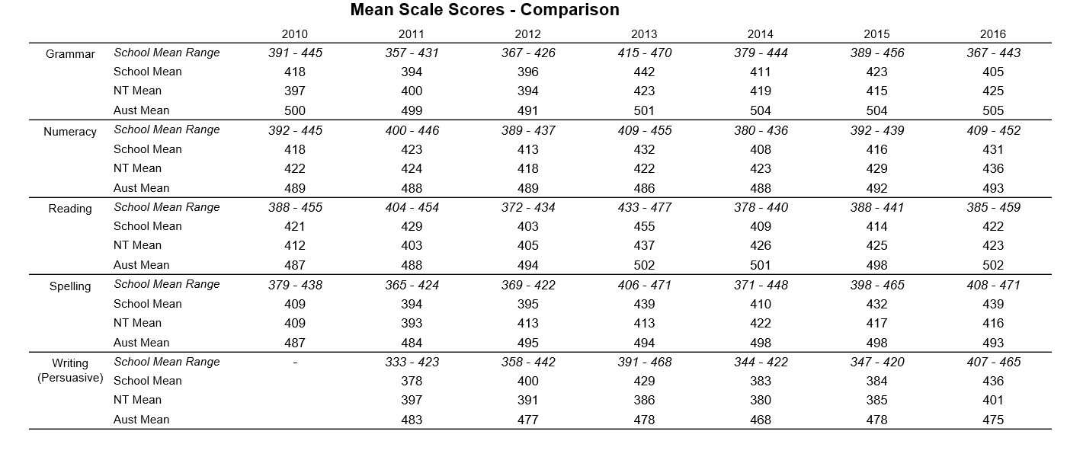

*Data to be provided by Performance and Data Management Branch:*

* *Number and percentage of students participating in NAPLAN for each domain*
* *Percentage of students achieving National Mean Scale*
* *Number and percentage of students below, at and above National Mean Scale for each domain and comparison against NT and national mean.*

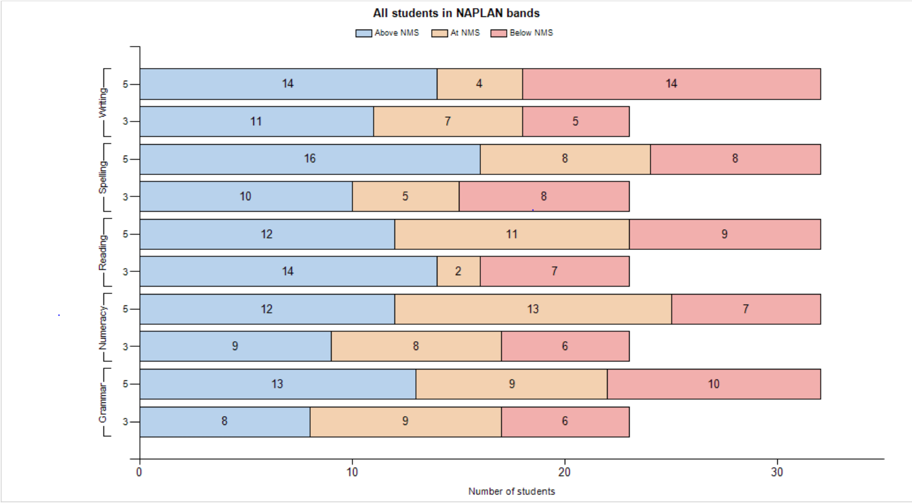

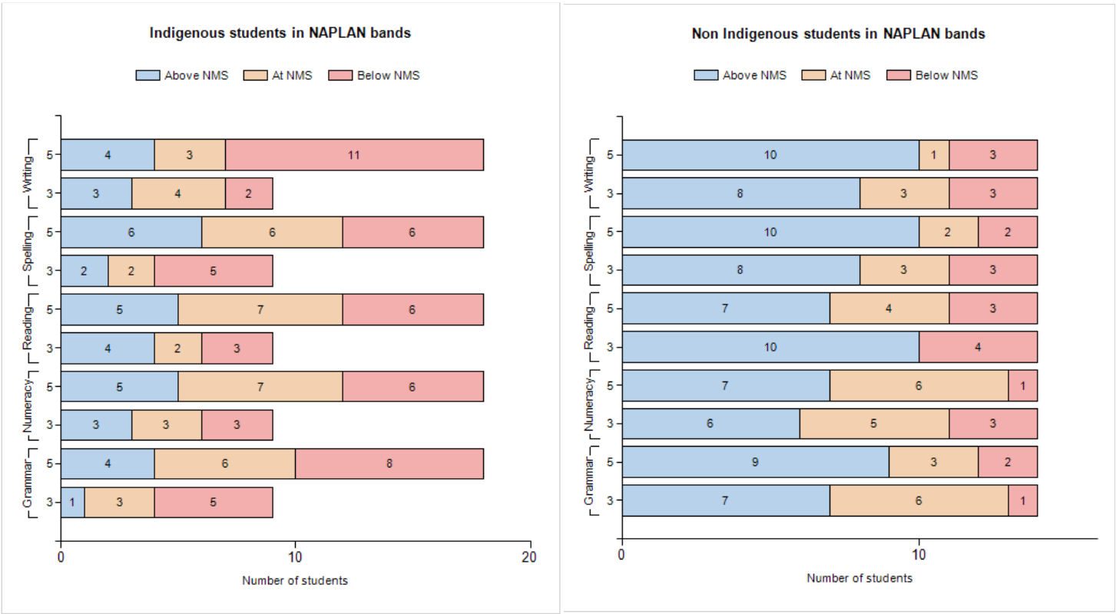

**ATTACHMENT C**

**Student Enrolment, Attendance and Learning**









**Karama School 2016 Annual Operation Plan (on a page)**

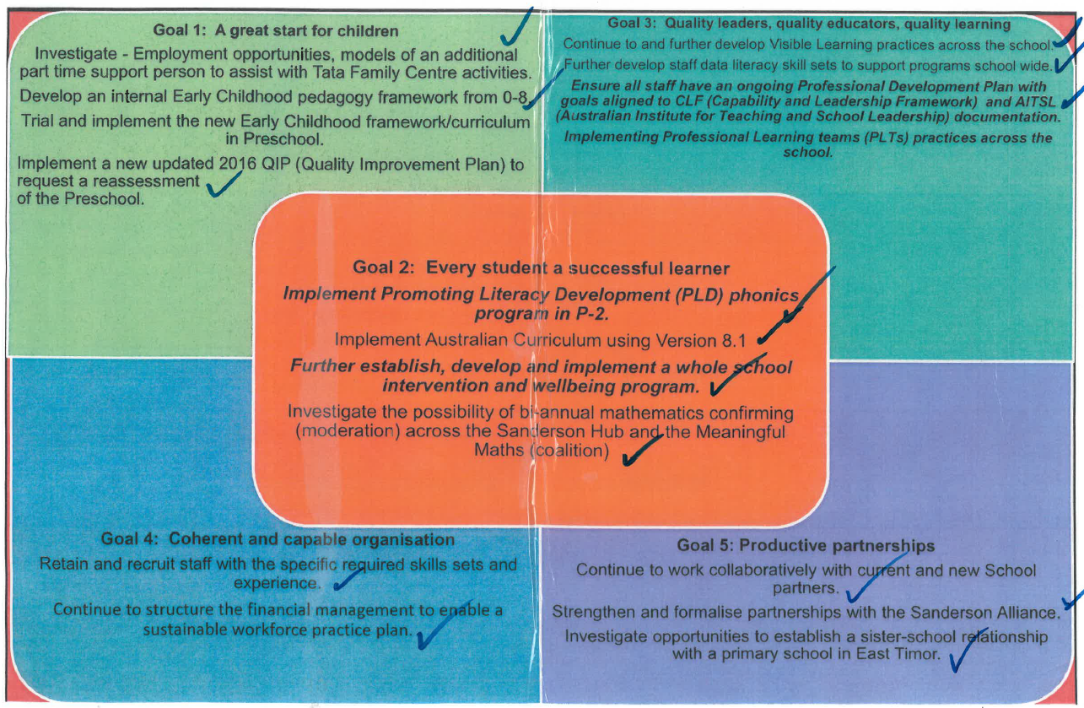*Include student enrolment and attendance data for all students and Indigenous students for each year level and whole school. For example:*